On-screen keyboards:does the presence of feedback or tactile landmarks improve typing performance

【Summary】:

Physical keyboards provide feedback and tactile landmarks that are not present on on-screen keyboards (OSKs). Similarly, physical keyboards provide faster typing speed than OSKs. The present study was designed to address the lack of research into the direct application of different types of feedback and tactile landmarks to on-screen typing with the intent of improving tablet OSK performance. Fourteen participants performed typing tasks using 6 tablet OSK variants: no feedback (the benchmark), audio feedback, visual feedback, haptic feedback, key-shaped tactile landmarks, and inverse tactile landmarks with ridges over the key gaps.

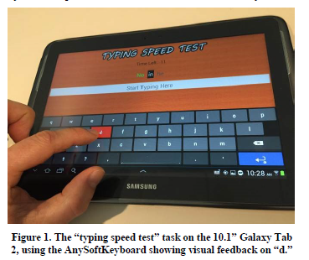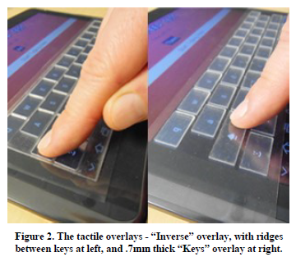

【Experiments】：

Apparatus：

Samsung Galaxy Tab 2

(The OSKs used the AnySoftKeyboard layout with the‘plain dark’theme (Figure 1), a commonly used, real-world OSK.)

Feedback settings:

No feedback or tactile landmarks

Visual feedback

Audio feedback

Haptic feedback

“Keys” tactile overlay

“Inverse” tactile overlay

Procedure：

A typing test (“Typing Speed Test” in Android OS) was used, which presented a series of randomized words in sentence format, including commas, periods, and capitalizations. Participants were asked to type as quickly and accurately as possible, while maintaining their natural OSK typing style. Users could correct errors within the current word if they desired, but not previous words. Previous words were highlighted green or red if typed correctly or incorrectly, respectively. Autocorrect was not enabled. The interface position on the screen was the same for all keyboards. The software automatically calculated net typing speed (the gross typing speed minus the number of words with errors, expressed in words-per-minute (WPM)) and accuracy (the percentage of words typed correctly). The software did not capture the number of typos within a misspelled word, nor any corrections made.

Results：

The typing performance results are shown in Figures 3 and 4. The subjective ranking is shown in Figure 5.

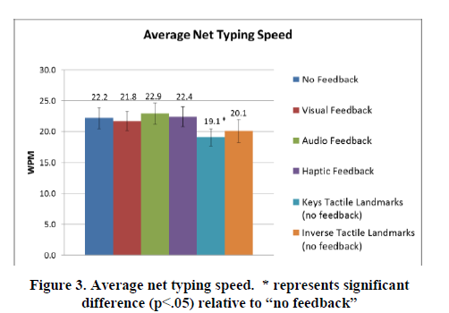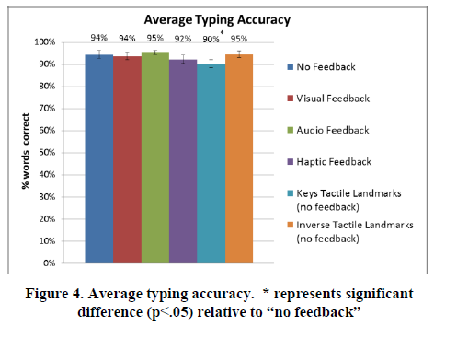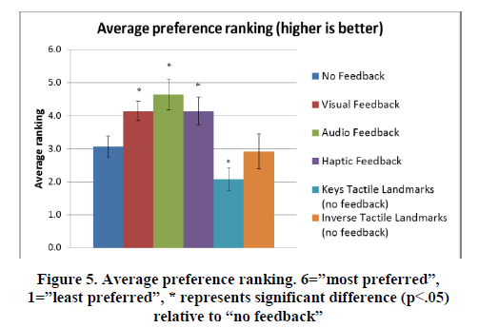

Experimental discussion: (see the paper Discuss for details)

1. OSKs and typing style - The paper discusses the advantages and disadvantages of the two keyboards.
2. Feedback - No significant difference
3. Tactile landmarks - The tactile overlay of the keys reduces typing performance and subjective preferences compared to the "no feedback" condition.

【Conclusion】：

The typing performance of the tablet's OSK has not improved with any feedback or tactile landmark conditions. Although feedback did not improve the typing performance of tablet-sized OSKs, it did affect how much people love a given keyboard design. Similarly, tactile landmarks alone do not improve typing performance. However, no conclusions have been drawn on the key tactile boundary due to the reduced sensitivity associated with this particular implementation.

【Important Reference】:

Alden, D., Daniels, R., Kanarick, A. (1972) Keyboard design and operation: a review of the major issues. Human Factors, 14(4), 275-293

Crump, M., Logan, G., (2010) Warning: this keyboard will deconstruct – the role of the keyboard in skilled typewriting. Psychonomic Bulletin & Review, 17 (3), pp. 394-399

Rosinski, R., Chiesi, H., Debons, A. (1980) Effects of amount of visual feedback on typing performance, Proceedings of 24th HFES, 1980

Monty, R., Snyder, H., Birdwell, G. (1983) Keyboard design: an investigation of user preference and performance. Proc of 27th HFES. 201-2015

Pollard, D., Cooper, M., (1979) The effect of feedback on keying performance, Applied Ergonomics, 10.4, 194-200

Kim, S., Lee, G., (2012) Typing on a touch surface: effect of feedback with horizontal touch keyboard and vertical display setup, APCHI, pp. 525-530